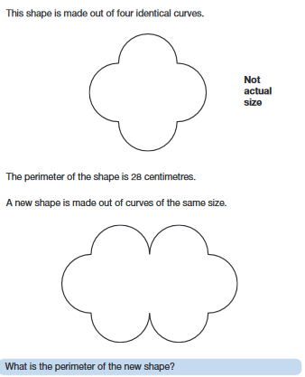
Going Deeper problem 1
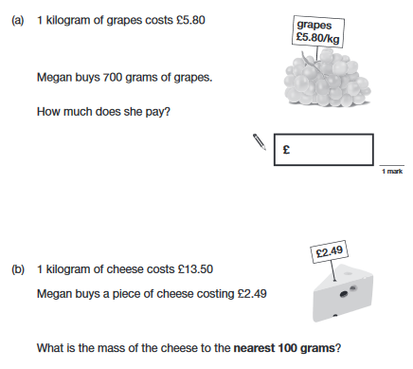
c) Use a different method to work out your answer.
d) Which method is the most efficient one to use? Explain

Going Deeper problem 2
a) 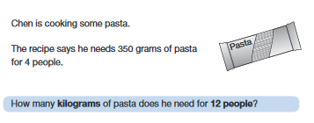
b) Show a visual/pictorial method to solve the problem.
c) Which method (there might be more thatn the two you used in part a and b)nis the most efficient one to use and which one are you most confident give you the correct answer? Explain.

Going Deeper problem 3
a) What is the perimeter of the new shape?
b) Can you estimate the perimeter of the third shape in the pattern?
c) Create a rule (or formula) which will work for any size shape made from these identical curved.

Going Deeper problem 4
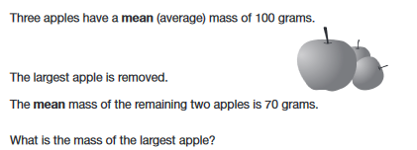
a) What would be a silly answer to the question – explain why you know it is a silly answer.
b) Work out the mass of the largest apple.

