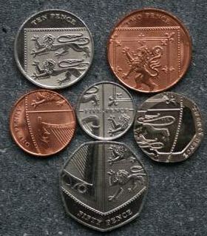
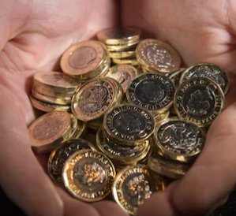
1 – Money problems

1) Write three different ways to make 27p:

2) What is the fewest number of coins needed to make 49p?
What are they?

3) What is the total amount of money needed to make the shield that links them all (top right picture)?

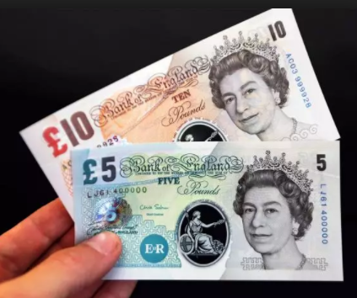
4) What is the fewest number of coins and notes needed to make £13.11?

5) Write down three ways to make £5.45.

6) Write three ways to make £250 (using notes only).

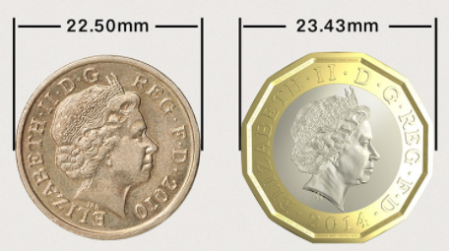
7) How much longer would a line of five new £1 coins be than old £1 coins?

