3 Whole numbers (integers) x mixed number
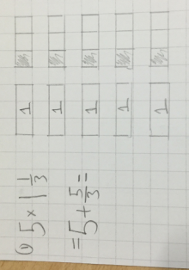
Draw a method to solve:
1) $5 x 1 \frac{1}{3}$ =
2) $3 x 2 \frac{3}{4}$ =
3) $5 x 1\frac{2}{5}$ =
4) $3 x 1\frac{7}{8}$ =
5) $2 x 2\frac{6}{10}$ =
6) $4 x 1 \frac{2}{7}$ =
7) $3 x 2 \frac{1}{2}$ =
8) $3 x 1 \frac{7}{8}$ =

3 Whole numbers (integers) x mixed number
Draw a method to solve:
1) $5 x 1 \frac{1}{3}$ =
2) $3 x 2 \frac{3}{4}$ =
3) $5 x 1\frac{2}{5}$ =
4) $3 x 1\frac{7}{8}$ =
5) $2 x 2\frac{6}{10}$ =
6) $4 x 1 \frac{2}{7}$ =
7) $3 x 2 \frac{1}{2}$ =
8) $3 x 1 \frac{7}{8}$ =
3 Whole numbers (integers) x mixed number
Draw a method to solve:
1) $5 x 1 \frac{1}{3}$ =
2) $3 x 2 \frac{3}{4}$ =
3) $5 x 1\frac{2}{5}$ =
4) $3 x 1\frac{7}{8}$ =
5) $2 x 2\frac{6}{10}$ =
6) $4 x 1 \frac{2}{7}$ =
7) $3 x 2 \frac{1}{2}$ =
8) $3 x 1 \frac{7}{8}$ =

3 Whole numbers (integers) x mixed number
Draw a method to solve:
1) $5 x 1 \frac{1}{3}$ =
2) $3 x 2 \frac{3}{4}$ =
3) $5 x 1\frac{2}{5}$ =
4) $3 x 1\frac{7}{8}$ =
5) $2 x 2\frac{6}{10}$ =
6) $4 x 1 \frac{2}{7}$ =
7) $3 x 2 \frac{1}{2}$ =
8) $3 x 1 \frac{7}{8}$ =

